Leaning Tree Farm – Herd Dispersal Sales List
(Updated by Leslie on 7/12/16 – Only Available Goats Are Listed )

Leaning Tree Herd Dispersal - Full Blood Buck Kids:
“Leaning Tree TU. Silversmith F3”; A really solid, growthy buck worth taking a serious look at if you want to add a quality buck kid to your breeding program. ABGA #10707149; DOB 1/5/16; Traditional; “Capriole’s Time’s Up” son, out of “Leaning Tree FB. Silver Flash C49” (a Silver Belle daughter); both sire and dam are exceptional animals; Silversmith is very friendly; I can’t get a good pic of him when taking pics by myself. I’ll keep working on it, or you can come see him in person! Teats are 1+1. Price $900.
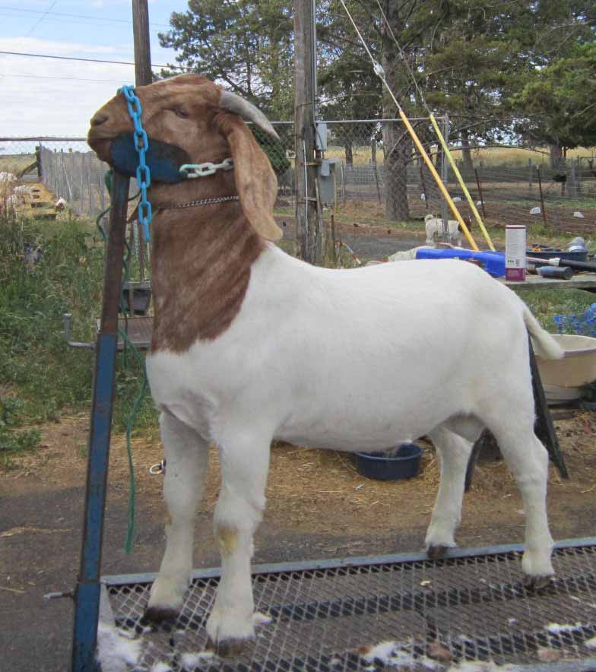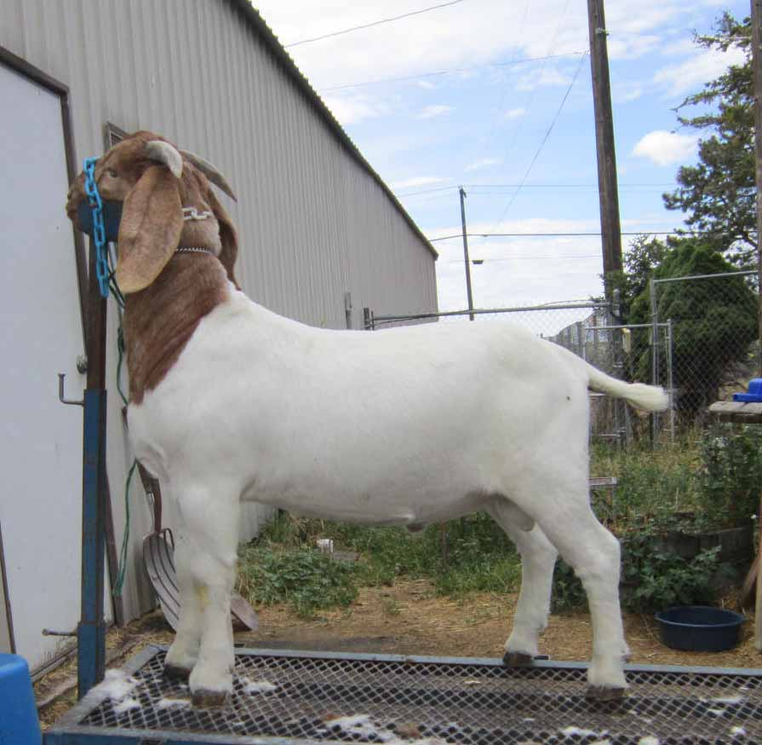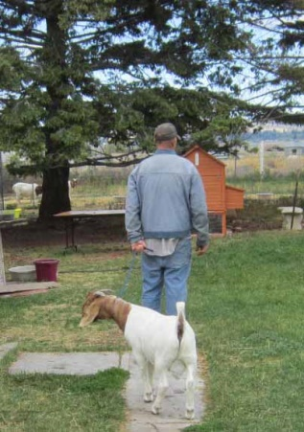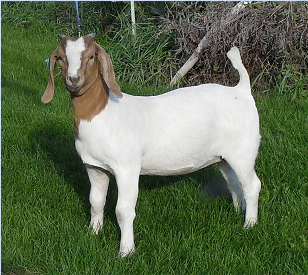
Silversmith F3 above 2 & on left ….. His INCREDIBLE grand dam Silver Belle A60 on right

"Leaning Tree IR. Mambo King F19" (Solid white blaze) & brother
"Leaning Tree IR. Maiko F18" (Broken blaze).
Nice quad brothers! The only way they would "pose" for the camera was off-lead and running together! DOB 1/16/16.
Dam is my favorite show doe "Leaning Tree GF Mambo B120", a G-Force *Ennobled* daughter.
Sire is the red buck "De Leon Farm Ima Rockstar"; Chicken On A Chain *Ennobled* Grandson.
Registrations applied for.
Current prices/teats: Mambo King F19 $850 / teats 2+2 clean. Maiko F18 $750 / teats 2+2 with tiny extra nub on 1 side.
Prices are subject to increase later this summer.
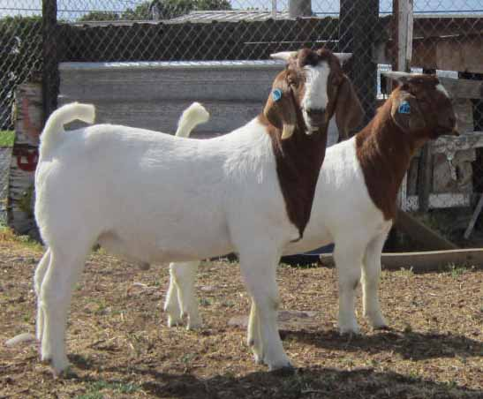 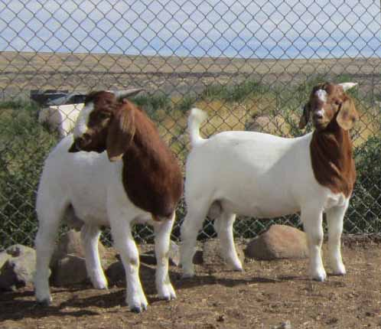
Mambo King in foreground / Maiko in background Mambo King (left) / Maiko (right)

“Leaning Tree FL. Painted Warrior F34”; ABGA # 10714343; DOB 2/10/16; 97% PUREBRED buck kid. As his name implies, he’s a PAINT. If you are looking for a quality buck for your purebred, % or commercial does, look no further! Painted Warrior is out of an incredible doe line, with excellent mothering ability and milk production! If you know much about my herd, you can fully appreciate this boy’s pedigree! Both his sire and dam are truly outstanding animals! Painted Warrior’s teats are 1+1, and his bite and pigment are also show correct. Painted Warrior’s ABGA registration is applied for. He is priced at $550. Picture coming soon!

Leaning Tree Farm Herd Dispersal – ADULT Percentage Does:
“Leaning Tree GF. Prize Z67” 88% ; Very successful show career with 86 individual points – both sisters have earned exactly 86 points! Talk about competing with each other! Twin sister to Playgirl (pictured with Playgirl at the right below; she’s the doe on the right of the 2 sisters); often shown & won together!; Prize has a huge frame & great length; ABGA #10530878; DOB 12/11/2010; Traditional w/ cape; Sired by “C S B Gauge’s G-Force *Ennobled*”; Out of “Leaning Tree T. Painted Lady **Doe of Excellence**”; Pics available on www.leaningtreefarm.com; Price $850. Prize is available now. She is currently being exposed (since 6/16/16) to our outstanding yearling buck “Leaning Tree RR. Flintlock E5”; who is sired by Capriole’s Red Rock Flint & out of ”Leaning Tree BH. Charisma”; a beautiful Ben Hur daughter with excellent milk production and mothering ability. Her kids should be incredible!
Note: I love this beautiful show doe, but she has rejected ONE of her kids 2 years in a row, despite my intervening. That needs to be disclosed, so there are no surprises if you purchase her.
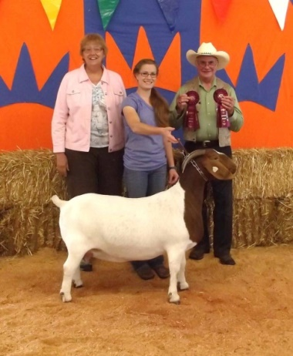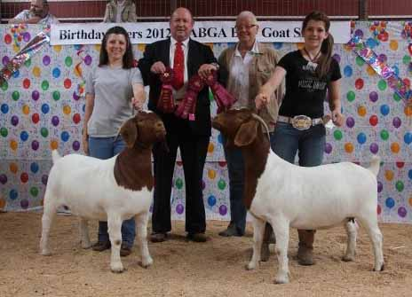

“Leaning Tree GF. Wty2 Flower F25” & “Leaning Tree GF. Wty2 Spice F26”. ABGA #’s 10709977 & 10709978. Two very nice 50% doeling sisters sired by “C S B Gauge’s G-Force *Ennobled*”. Their dam is our very milky 50% Saanen / 50% Oberhasli dairy doe that we call “Wattles”. Both doelings have perfect 1+1 teats, and correct pigment and bites. These girls would make excellent foundation does for those who enjoy (like me!) percentage doe programs that “breed up” generations to produce true percentage show does, or for use as recip does due to their milk production background! Flower & Spice’s dam blood-tested NEGATIVE on 4/26/16 for CAE, CL, Johne’s & Q-Fever. Pictured below Spice on left; Flower on the right. Price for each doeling is $300; or $500 for the pair together.
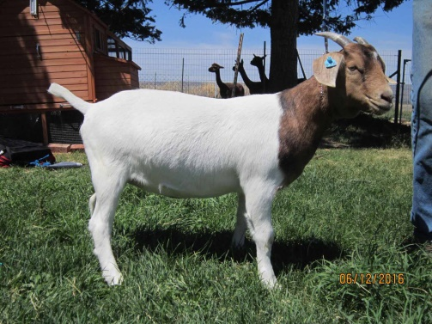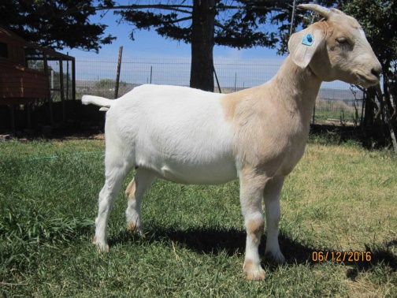

Leaning Tree Farm Herd Dispersal – ADULT Full Blood &Purebred Does:
“De Leon Farms Sucha Smash” DOB 3/13/2014; ABGA #10660624; a shy doe who becomes a very protective, incredible mother at kidding; raising all 3 buck kids (4H wethers) from her first kidding; Out of "Leaning Tree GF. Silver Sunrise", a show doe that is full sister to my favorite doe of all-time "Leaning Tree GF. Silver Belle A60". Smash is sired by "AFB2 One Step Closer", a "Lewis Creek Bono *Ennobled*" son.
Price $850. The pics below were taken in her “working clothes” on the day we weaned her last son. She’s available any time; in great condition. Smash is currently being exposed to our outstanding yearling buck “Leaning Tree RR. Flintlock E5”; who is sired by Capriole’s Red Rock Flint & out of ”Leaning Tree BH. Charisma”; a beautiful Ben Hur daughter with excellent milk production and mothering ability.
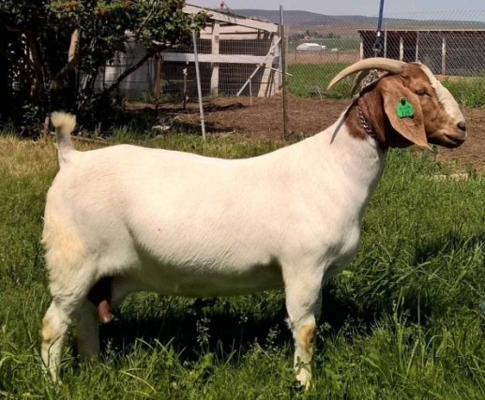
Leaning Tree Farm Herd Dispersal – JUNIOR Full Blood & Purebred Does:
“Leaning Tree FL. Brash-N-Sassy F28” DOB 1/31/16; ABGA # 10714340; A stylish, eye-catching full blood doeling with “show ring” attitude. Her name says it all! She has never been shown, but I think she sure has show-potential. Brash-N-Sassy’s teats are 2+2 clean, and her bite and pigment are correct. Pics are coming soon. Price: $1,000. She is now old enough to be available!
“Leaning Tree GF. Boogie Girl F40” DOB 2/17/16; ABGA #10707163; A very correct full blood doeling with a great pedigree that includes ennobled greats such as CSB Gauge’s G-Force, RRD Gauge P529, RRD Ruger T307, 2DOX Amigo and many others! Boogie Girl’s teats are 1+1, and her bite and pigment are correct. Price: $800. Boogie Girl is still running with her dam, but can be weaned at any time!
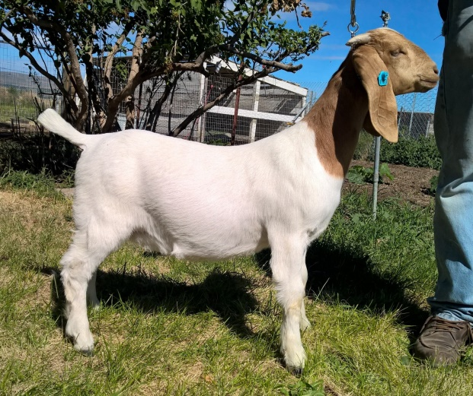

“Leaning Tree FL. Star Light F48 ” DOB 3/23/16; ABGA #10714344; A very feminine, level-topped full blood doeling with a great pedigree that includes greats such as CSB Gauge’s G-Force *Ennobled*, RRD Gauge P529 *Ennobled*, Capriole’s Red Rock aka “Flint”, 2DOX Amigo *Ennobled* and many others! Star Light’s teats are 1+1, and her bite and pigment are correct. Price: $800. Star Light can be weaned and ready to go on 6/23/16!
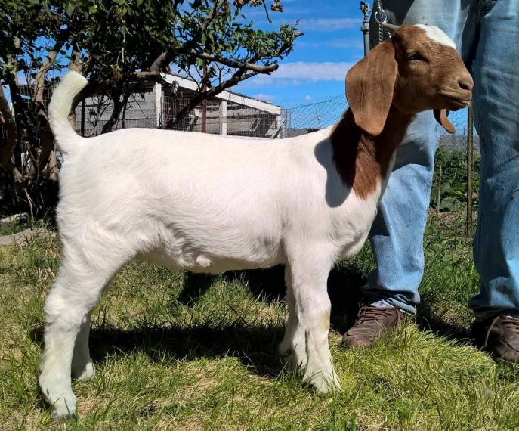

MANY MORE top quality breeding and show goats will be added to this list until we are sold out, so please check back often!
Availability, price & info on all goats listed is subject to change as goats are sold, or reassessed, so please check back often.
Thanks for looking!
Leslie
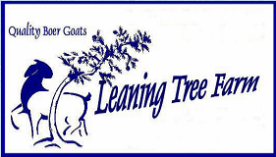
Leslie Bader-Robinson
Leaning Tree Farm
Lbader1@yahoo.com
(509) 246-9327 (farm)
(509) 750-1112 (cel)
PO Box 177
2084 Road 20 N.E.
Soap Lake, WA 98851
www.leaningtreefarm.com

